Pembrey Country Park
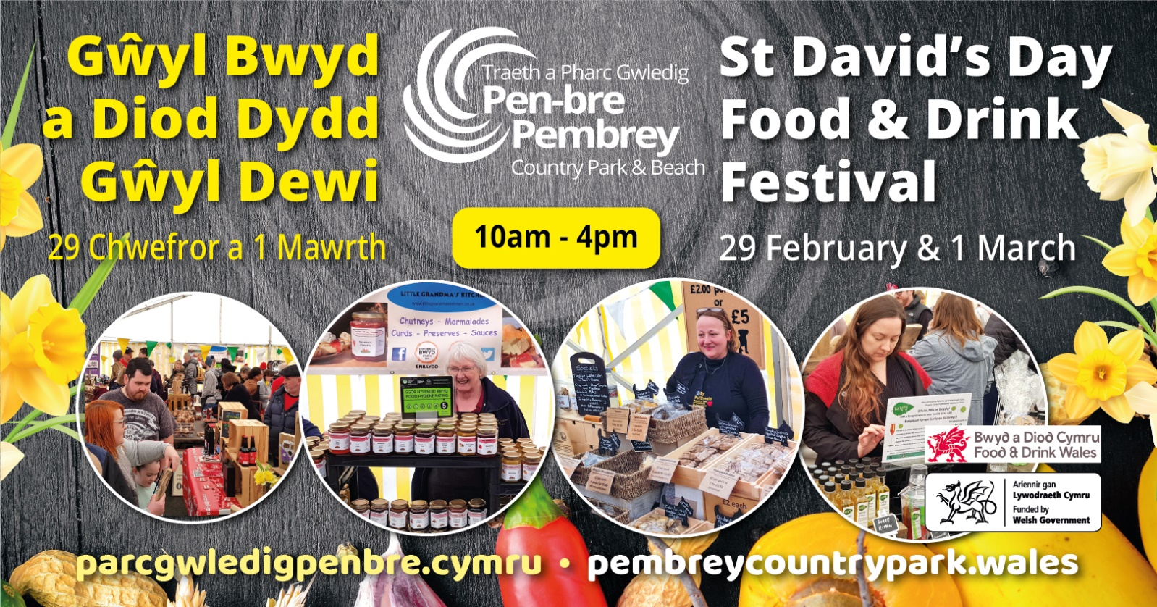
St David’s Day Food & Drink Festival
Expressions of Interest NOW OPEN
We invite you to submit an expression of interest to join us at our Food & Drink Festival. Following on from the success of last year’s event, Pembrey Country Park are hosting a 2 day St David’s Day Food & Drink Festival (29th Feb & 1 Mar) celebrating local Food & Drink to our thousands of people who visit the park.
Last year most of our stall holders sold out very early on due to the high level of visitors we encountered.
We would be delighted if you can join us.
We limit the number of similar stalls, this allows everyone a good chance of having a great day
Spaces are limited.
All stalls will be within a hard-standing marquee.
If you require further information or an electric copy of the Expression of Interest form, please contact llinmorris@carmarthenshire.gov.uk

Expression of Interest
Saturday 29th February & Sunday 1st March (10am – 4pm daily)
Please complete the form below with as much detail as possible with regards to what you would like to bring to the 2 day event.
Information Required
Name of Business

Contact Details

County

Email

Telephone Number

Brief Description of what you sell?
(add link to website if available)
Do you have a Hygiene Rating?*  *We are unable to accept anyone without a rating of 4 or above | Hygiene rating number……………………..
Number of table spaces required?
Do you have Liability Insurance? | Yes/No
Do you have a full risk assessment? | Yes/No
Are you a new Business trading for under 1 year? | Yes/No – If yes, how long for?
Costs:
Local produce Stalls  (6ft table – to be supplied by yourself) | £50.00 x 1 table space  £100.00 x 2 Table space
Catering | £200.00 per unit
Notes:
Please note this is purely an expression of interest, confirmation of your space and costs will be confirmed shortly.
Please email a copy of your insurance/risk assessment/food hygiene certificate with your application form
Please enclose a picture of your stand and any other required information.
Please note: refunds for non-attendance cannot be given due to limited spaces available
Please return form to : llinmorris@carmarthenshire.gov.uk

